WEEK 2
TASK 1:
SOLUTION:
import java.util.*;
import java.util.stream.*;

public class task1 {
public static void main(String[] args) {
try (Scanner sc = new Scanner(System.in)) {
System.out.print("Enter number of elements: ");
if (!sc.hasNextInt()) return;

int n = sc.nextInt();
List<Integer> list = new ArrayList<>();

System.out.println("Enter " + n + " integers:");
for (int i = 0; i < n; i++) {
if (sc.hasNextInt()) {
list.add(sc.nextInt());
}
}
int result = list.stream()
.distinct()
.sorted(Comparator.reverseOrder())
.skip(1)
.findFirst()
.orElseThrow(() -> new RuntimeException("Second highest not found (list too small or all elements identical)"));

System.out.println("Second Highest: " + result);
} catch (Exception e) {
System.err.println("Error: " + e.getMessage());
}
}
}
OUTPUT:
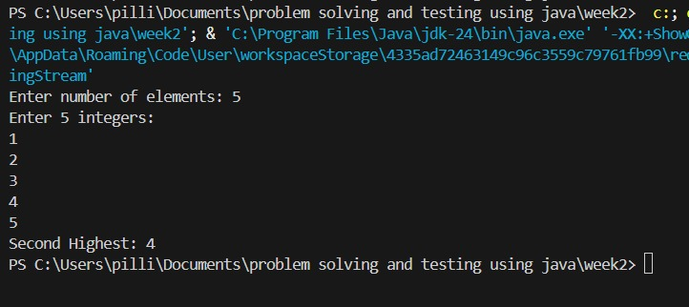

TASK 2:
SOLUTION:
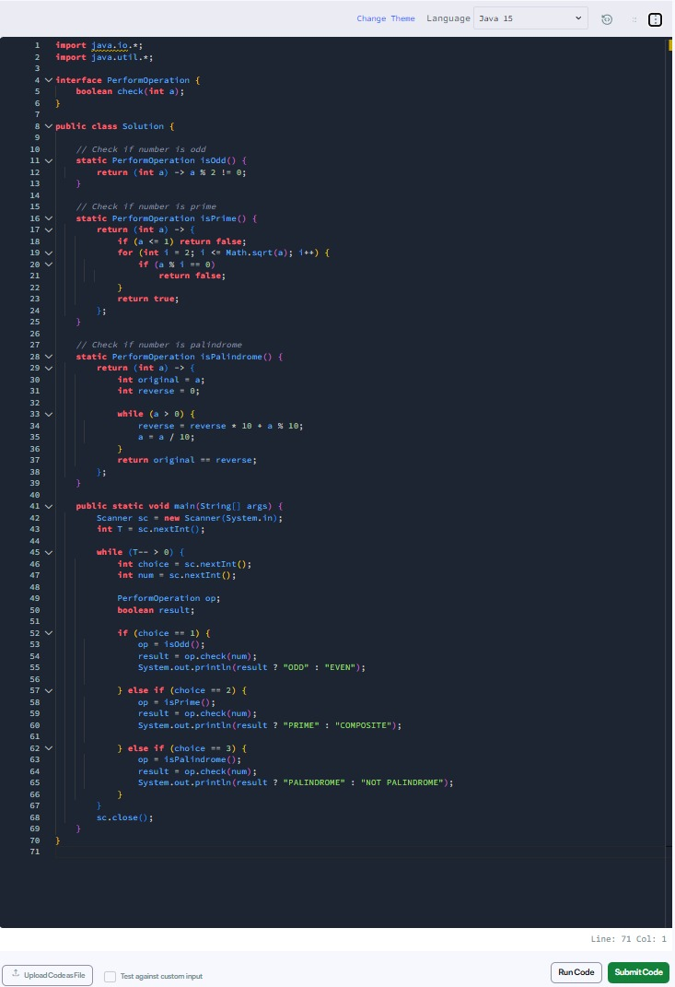
OUTPUT:
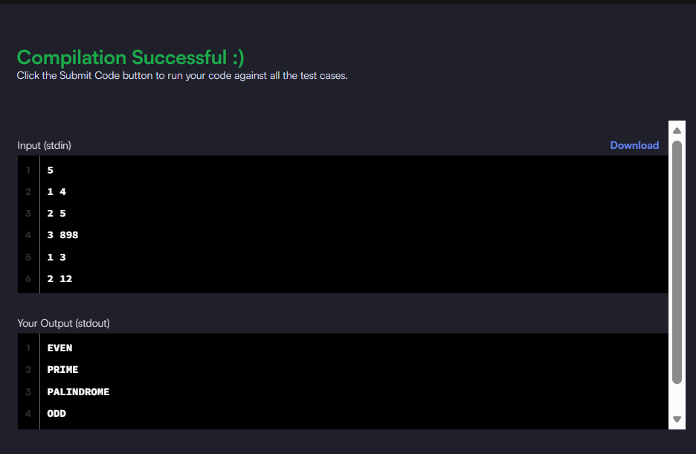

TASK 3:
SOLUTION:
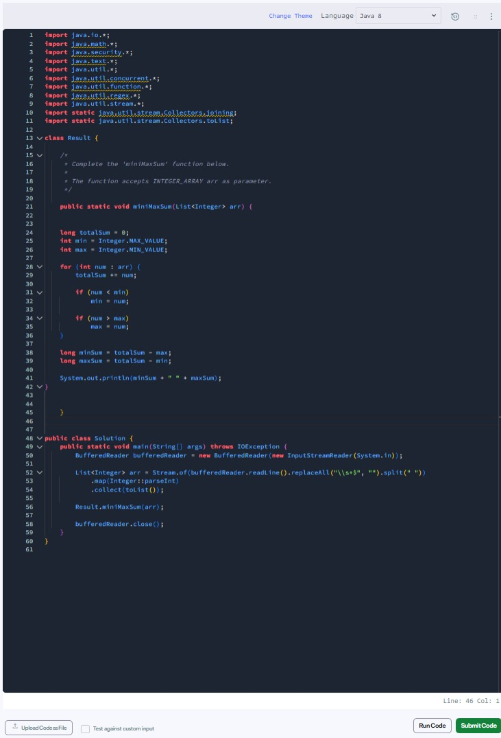
OUTPUT:
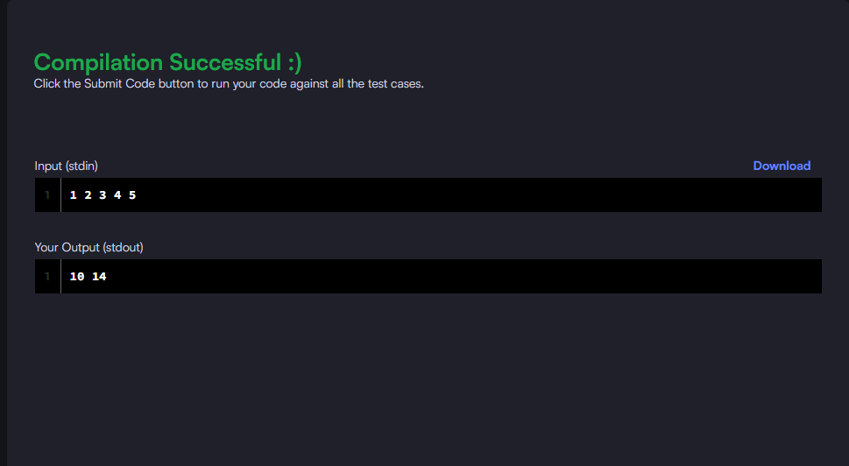

TASK 4:
import java.util.*;
import java.util.stream.*;

class Person {
private final String name;
private final int age;

Person(String name, int age) {
this.name = name;
this.age = age;
}

public String getName() { return name; }
public int getAge() { return age; }

// Static method for filtering
public static boolean isOlderThanLimit(Person p, int ageLimit) {
return p.getAge() > ageLimit;
}
}

public class task4 {
public static void main(String[] args) {
Scanner sc = new Scanner(System.in);

System.out.print("Number of people: ");
int n = sc.nextInt();

List<Person> persons = new ArrayList<>();
for (int i = 0; i < n; i++) {
persons.add(new Person(sc.next(), sc.nextInt()));
}

System.out.print("Enter age limit: ");
int ageLimit = sc.nextInt();

// 1. Sort names alphabetically
// Person::getName is a reference to an instance method of an arbitrary object
System.out.print("Sorted Names: ");
persons.stream()
.map(Person::getName)
.sorted(String::compareTo)
.forEach(name -> System.out.print(name + " "));
System.out.println();

// 2. Filter using static logic
// Note: Can't use :: here easily because of the extra 'ageLimit' parameter
System.out.print("Older than " + ageLimit + ": ");
persons.stream()
.filter(p -> Person.isOlderThanLimit(p, ageLimit))
.map(Person::getName)
.forEach(name -> System.out.print(name + " "));
System.out.println();

// 3. Instance method reference on a specific type
System.out.print("Uppercase: ");
persons.stream()
.map(Person::getName)
.map(String::toUpperCase)
.forEach(name -> System.out.print(name + " "));

sc.close();
}
}

OUTPUT:
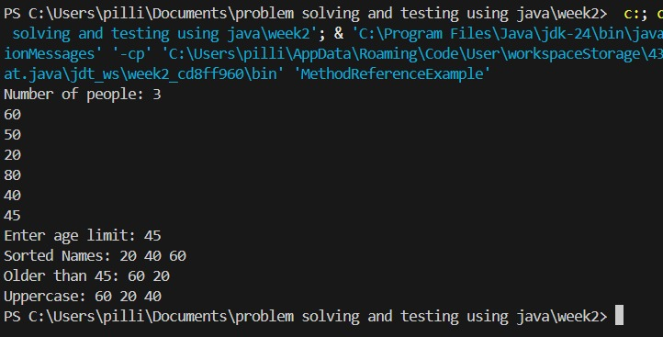

TASK 5:
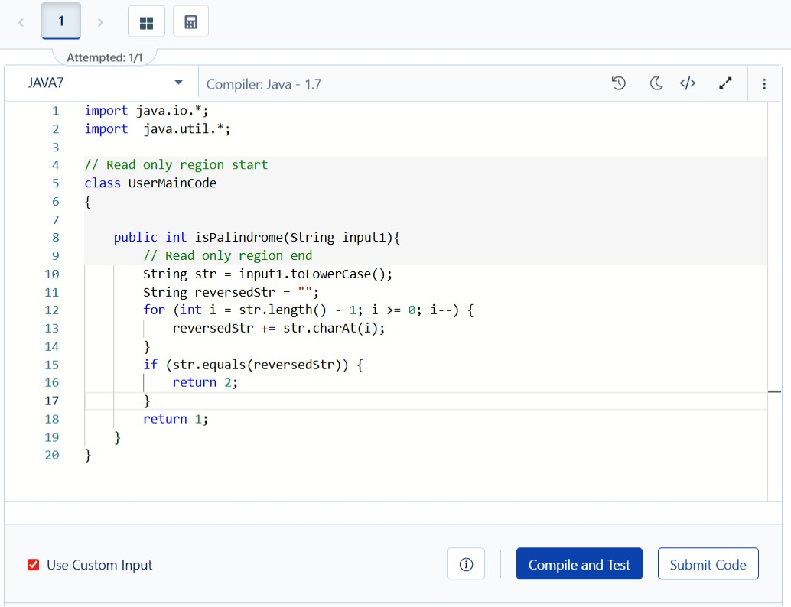

OUTPUT:
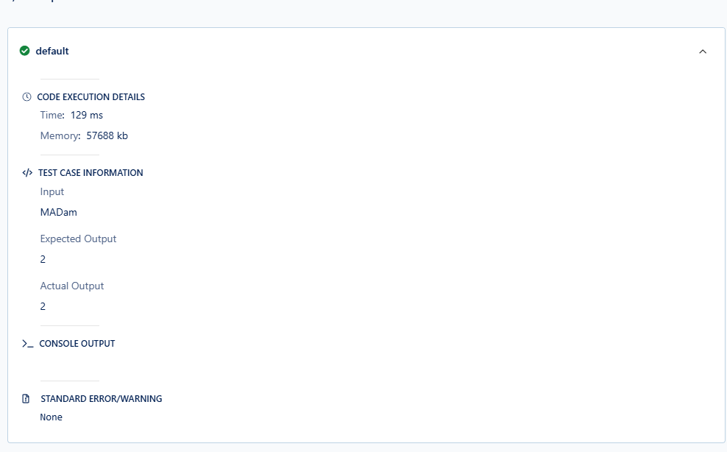

TASK 6:
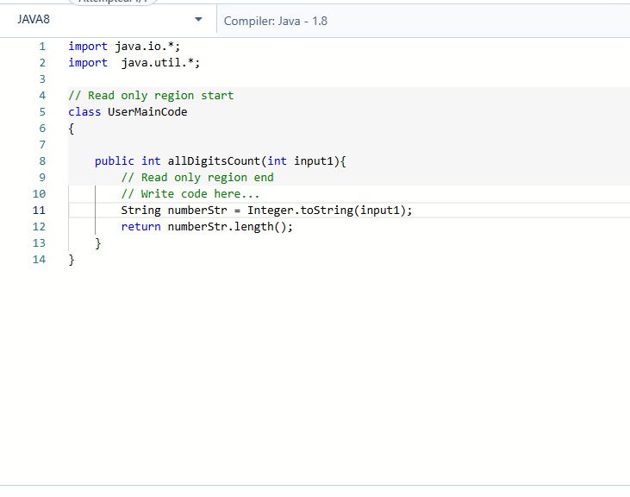
OUTPUT:
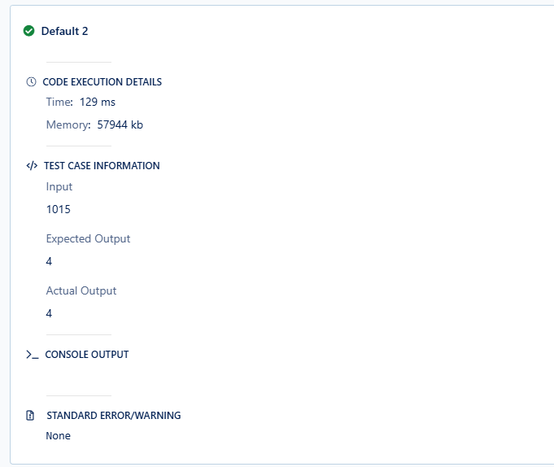

TASK 7:
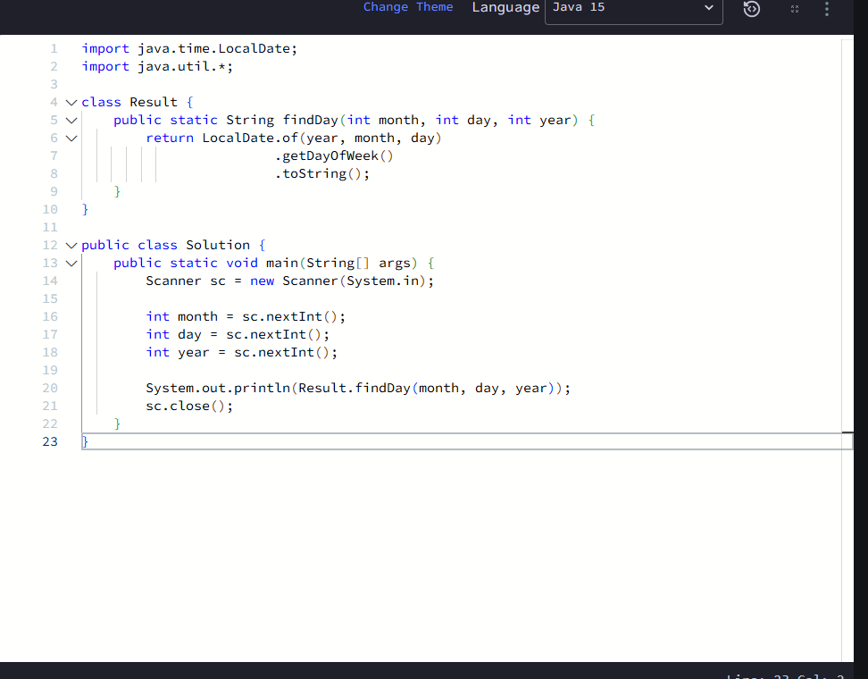

OUTPUT:
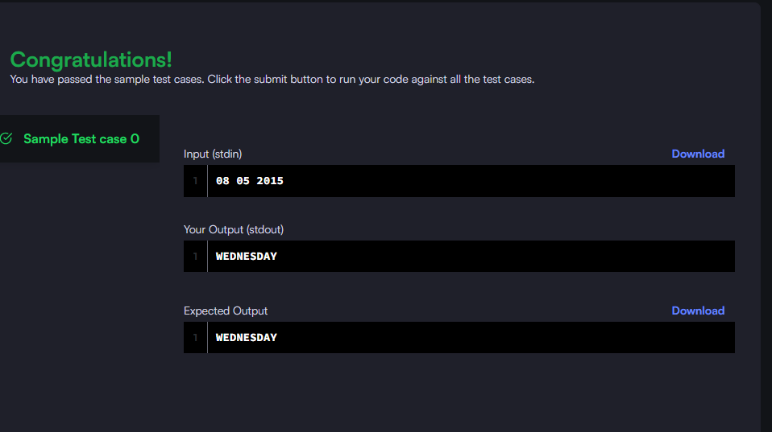

TASK 8:
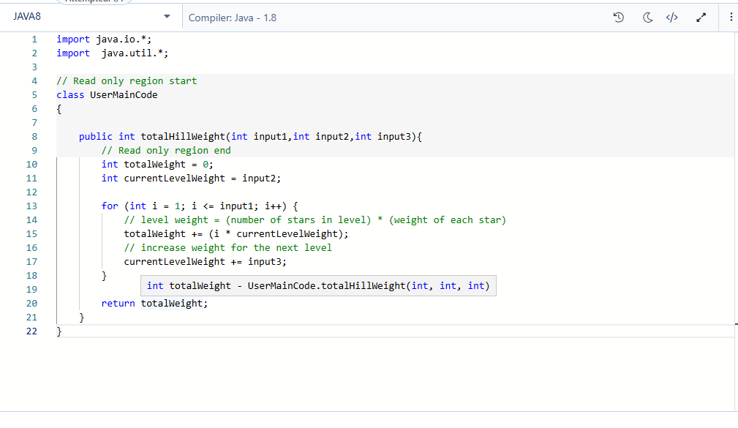

OUTPUT:
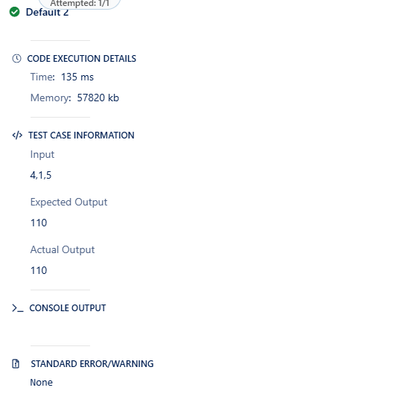

TASK 9:
import java.time.LocalDate;
import java.util.*;
import java.util.stream.*;

class Event {
private final String name;
private final LocalDate date;

Event(String name, String date) {
this.name = name;
this.date = LocalDate.parse(date); // Format: yyyy-MM-dd
}

public String getName() { return name; }
public LocalDate getDate() { return date; }
}

public class task9 {
public static void main(String[] args) {
try (Scanner sc = new Scanner(System.in)) {
System.out.print("Number of events: ");
if (!sc.hasNextInt()) return;
int n = sc.nextInt();

List<Event> events = new ArrayList<>();
for (int i = 0; i < n; i++) {
events.add(new Event(sc.next(), sc.next()));
}

System.out.print("Enter month filter (1-12): ");
int month = sc.nextInt();

// 1. Sort and Display All
System.out.print("Chronological: ");
List<Event> sortedEvents = events.stream()
.sorted(Comparator.comparing(Event::getDate))
.collect(Collectors.toList());

sortedEvents.forEach(e -> System.out.print(e.getName() + " "));
System.out.println();

// 2. Earliest & Latest using Stream Min/Max (Safer than get(0))
events.stream()
.min(Comparator.comparing(Event::getDate))
.ifPresent(e -> System.out.println("Earliest: " + e.getName()));

events.stream()
.max(Comparator.comparing(Event::getDate))
.ifPresent(e -> System.out.println("Latest: " + e.getName()));

// 3. Events in specific month
System.out.print("Events in month " + month + ": ");
long count = events.stream()
.filter(e -> e.getDate().getMonthValue() == month)
.peek(e -> System.out.print(e.getName() + " "))
.count();

if (count == 0) System.out.print("None found.");
System.out.println();
}
}
}

OUTPUT:
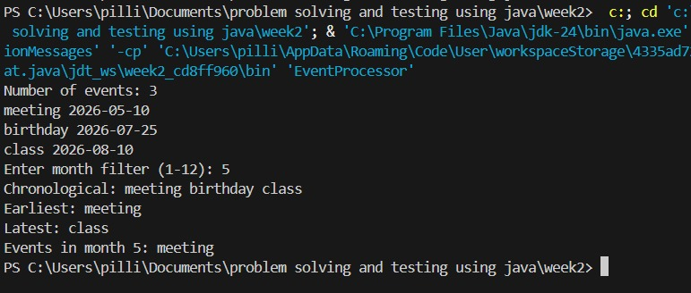

TASK 10:
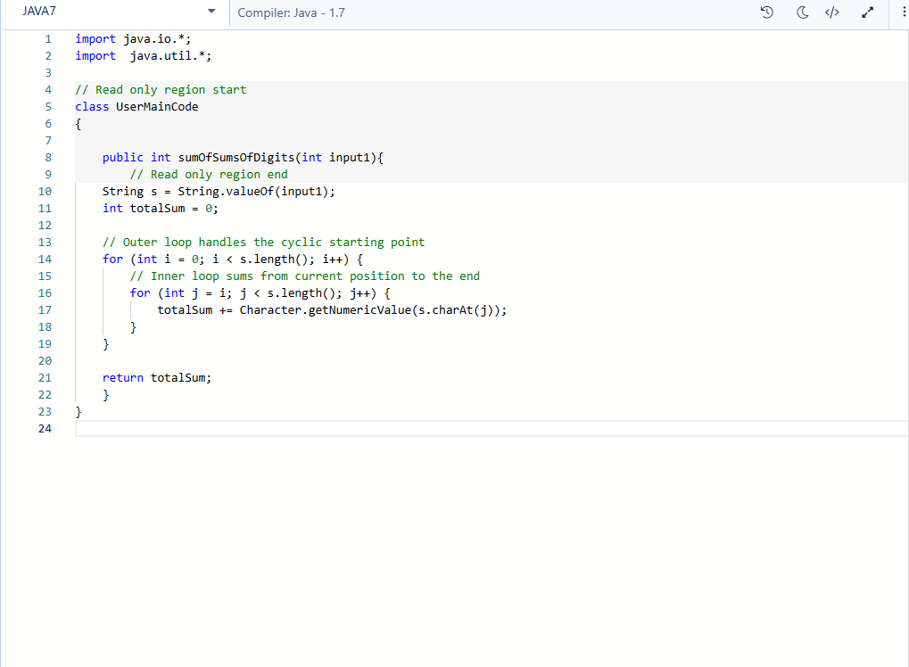

OUTPUT:
